 | 7.0.9 Editors - 3D Viewport - Curve + Surface Object - Edit Mode - Curve context menus
Table of content
Curve context menu 3
Subdivide 3
Last Operator Subdivide 3
Number of Cuts 3
Extrude Curve 3
Last operator Extrude Curve and Move 3
Mode 4
Move X , Y , Z 4
Orientation 4
Proportional editing 4
Proportional Falloff 4
Proportional Size 4
Connected 4
Projected(2D) 4
Make Segment 4
Duplicate 4
Last Operator Duplicate 5
Move X , Y , Z 5
Orientation 5
Proportional editing 5
Proportional Falloff 5
Proportional Size 5
Connected 5
Projected(2D) 5
Radius 5
Last Operator Shrink/Fatten 5
Offset 6
Offset Even 6
Proportional editing 6
Proportional Falloff 6
Proportional Size 6
Connected 6
Projected(2D) 6
Tilt 6
Last Operator Tilt 6
Angle 6
Proportional editing 6
Proportional Falloff 6
Proportional Size 7
Connected 7
Projected(2D) 7
Clear Tilt 7
Smooth 7
Smooth Curve Tilt 7
Smooth Curve Radius 7
Mirror 7
Interactive Mirror 7
X Global, Y Global etc. 7
Last Operator Mirror 8
Orientation 8
Constraint Axis 8
Proportional editing 8
Proportional Falloff 8
Proportional Size 8
Connected 8
Projected(2D) 8
Snap 8
Last Operator Snap 8
Offset 8
Set Spline Type 9
Last Operator Set Spline Type 9
Type 9
Handles 9
Set Handle Type 9
Auto 9
Vector 9
Align 9
Free 9
Toggle Free/Aligned 9
Last Operator Set Handle Type 9
Type 9
Toggle Cyclic 10
Last Operator Toggle Cyclic 10
Direction 10
Switch Direction 10
Recalc Normals 10
Last Operator Recalc Normals 10
Length 10
Set Goal Weight 10
Set Curve Radius 11
Split 11
Decimate Curve 11
Last Operator Decimate Curve 11
Ratio 11
Separate 11
Dissolve Vertices 11
1Delete Segment 11
Delete Point 12
Delete 12
Show/Hide 12
Show Hidden 12
Hide Selected 12
Last Operator Hide Selected 12
Unselected 12
Hide Unselected 12

Curve context menus
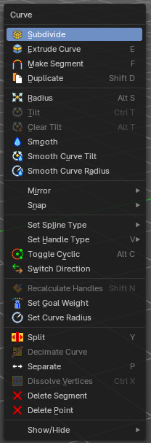
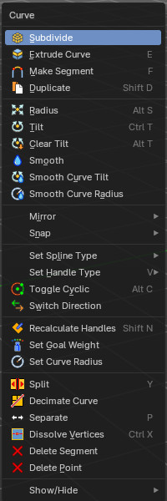
Call this menu with double right click in the 3D viewport. You need to be in Edit mode with a Curve or a Surface object.

With a surface object some options are greyed out.

Subdivide
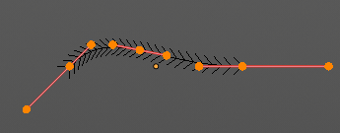
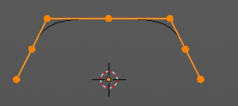
Subdivides the selected curve geometry, and adds more control points.

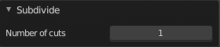
Last Operator Subdivide

Number of Cuts
Number of subdivision cuts.

Extrude Curve
Extrudes the selected curve point(s).

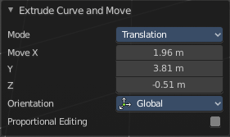
Last operator Extrude Curve and Move

Mode
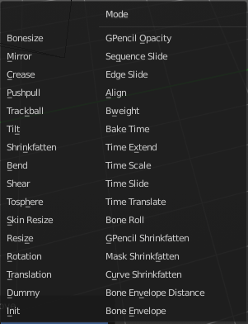
A drop-down box where you can choose between different extrude modes.
Default is Translation. Most other methods has no effect.

Move X , Y , Z
The position of the extruded point(s).


Orientation
Adjust the orientation of the extrusion. It usually starts with Normal.

Proportional editing

Enables proportional editing. Activating proportional editing reveals further settings.

Proportional Falloff
Adjust the falloff methods.

Proportional Size
See and adjust the falloff radius.

Connected
The proportional falloff gets calculated for connected parts only.

Projected(2D)
The proportional falloff gets calculated in the screen space. Depth doesn't play a role. When it's in the radius, then it gets calculated.

Make Segment
Joins two curves by adding a segment between the end of the one and the beginning of the other. You can also create a closed curve that way.

Duplicate
Duplicates the current selection. This can be a single control point or a whole curve.
The copy sticks to the mouse until you release it. A Right click while moving will reset the position of the duplicate. The duplicated part will be part of the same object.
When you drag the duplicate around you will see the position values in the header.


Last Operator Duplicate

Move X , Y , Z

Orientation
Choose the orientation.

Proportional editing
Enables proportional editing. Activating proportional editing reveals further settings.

Proportional Falloff
Adjust the falloff methods.

Proportional Size
See and adjust the falloff radius.

Connected
The proportional falloff gets calculated for connected parts only.

Projected(2D)
The proportional falloff gets calculated in the screen space. Depth doesn't play a role. When it's in the radius, then it gets calculated.

Radius
Scales the selected geometry along its normals. Transform orientation and Pivot point gets ignored.
A positive value pushes the vertices outwards. A negative value pushes the vertices inwards.


Last Operator Shrink/Fatten
The Last Operator Shrink/Fatten panel gives you tools to adjust the Shrink/Fatten operation. Here you have numeric input for the strength and a few more options.

Offset
Offset is the strength of the offset for Shrink/Fatten.

Offset Even
Offset Even scales the selection to give more thickness in even areas.

Proportional editing
Enables proportional editing. Activating proportional editing reveals further settings.

Proportional Falloff
Adjust the falloff methods.

Proportional Size
See and adjust the falloff radius.

Connected
The proportional falloff gets calculated for connected parts only.

Projected(2D)
The proportional falloff gets calculated in the screen space. Depth doesn't play a role. When it's in the radius, then it gets calculated.

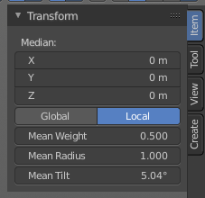
Tilt
Modifies the Mean Tilt.
Activate the tool, and drag the mouse. You will see a value in the header now. The selected curve path will rotate by dragging the mouse.
The Tilt angle always starts at zero. It is relative. To modify the Mean Tilt use the edit box in the Transform panel.

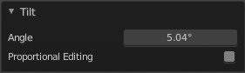
Last Operator Tilt

Angle
The Tilt angle.

Proportional editing
Enables proportional editing. Activating proportional editing reveals further settings.

Proportional Falloff
Adjust the falloff methods.

Proportional Size
See and adjust the falloff radius.

Connected
The proportional falloff gets calculated for connected parts only.

Projected(2D)
The proportional falloff gets calculated in the screen space. Depth doesn't play a role. When it's in the radius, then it gets calculated.

Clear Tilt
Sets the Mean Tilt to zero.

Smooth
Flattens the angles of the selected control point(s).

Smooth Curve Tilt
Smooths the curve tilt of the selected control point(s).

Smooth Curve Radius
Smooths the curve radius of the selected control point(s).

Mirror
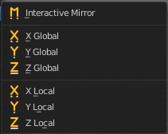
Mirror mirrors the selected geometry along the defined axis.

Interactive Mirror
Mirror by hotkeys. You activate the tool, type in x for x global for example, or x x for x local. And the selection gets mirrored.

X Global, Y Global etc.
Mirrors the selection around the chosen axis.

Last Operator Mirror

The Last Operator Mirror panel gives you tools to adjust the mirror action.

Orientation
Orientation is a drop-down box choose the type of orientation for the mirroring action.

Constraint Axis
Constraint Axis gives you again the possibility to define the mirror axis. You can choose more than one axis here.

Proportional editing
Enables proportional editing. Activating proportional editing reveals further settings.

Proportional Falloff
Adjust the falloff methods.

Proportional Size
See and adjust the falloff radius.

Connected
The proportional falloff gets calculated for connected parts only.

Projected(2D)
The proportional falloff gets calculated in the screen space. Depth doesn't play a role. When it's in the radius, then it gets calculated.


Snap
Choose several methods to snap one element to another. The menu items should be self explaining.

Last Operator Snap

Some snap operations shows a last operation panel, some not.

Offset
If the selection should snap as a whole, or if each individual element of the selection should snap.

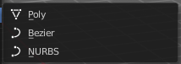
Set Spline Type
With set Spline Type you can set the type of the curve.
Poly is a straight line between the control points. Bezier has curve handlers. A nurbs curve has a control cage.




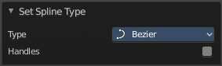
Last Operator Set Spline Type

Type
Type is a drop-down box choose the spline type

Handles
Use Handles when converting Bezier curves into polygons.

Set Handle Type

Handles defines the type of handle for the knots of the curve. You have the choice between Auto, Vector, Align and Free. And the Last Operator gives you a fifth possibility to toggle between Free and Align.

Auto
Auto aligns the handles automatically.

Vector
Set Handle type to Vector.

Align
Set Handle type to Align.


Free
Set Handle type to Free.

Toggle Free/Aligned
Toggle Free/Aligned.


Last Operator Set Handle Type

Type
Type is a drop-down box where you can set the handle type. You have the choice between Auto, Vector, Align, Free. And the fifth possibility toggles between Free and Align.

Toggle Cyclic

Toggle Cyclic closes or opens the curve.

Last Operator Toggle Cyclic

Direction
Direction is a drop-down box choose the direction in which the curve gets closed.

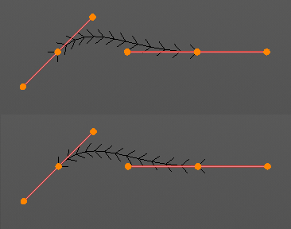
Switch Direction
Just for Bezier Curve object type. Surface Nurbs curves doesn't have a direction. Switches the direction in which the curve is pointing.

Recalc Normals
Recalculates the normals of the selected curve.

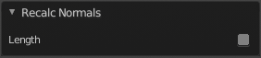
Last Operator Recalc Normals

Length
Recalculates the handle length too.

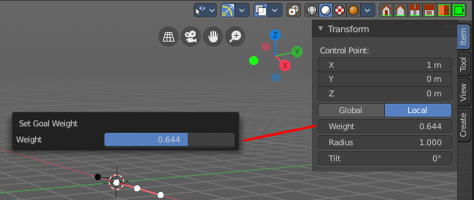
Set Goal Weight
Sets the curve’s Weight for the selected control point to the specified value. If more than one control point is selected this will set the Mean Weight.

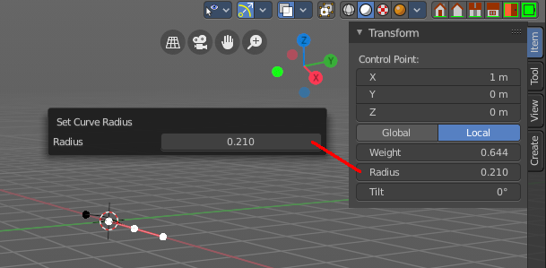
Set Curve Radius
Sets the curve radius for the selected curve point to the specified value.

Split
Splits the curve at the selected control point(s). You need to select two control points to select the segment between it.

Decimate Curve
Decimates the currently selected geometry. It starts with a Ratio of 1. Which means no decimation. The lower the ratio the more decimation you will get.

Last Operator Decimate Curve

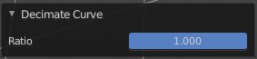
Ratio
Adjust the strength of decimation.

Separate
Separates the selected control points, and creates a new curve object out of it. You need to select two control points to select the segment between it.

Dissolve Vertices
Dissolves the selected vertices. When removing vertices in between then the curve stays intact and connected.

1Delete Segment
Removes the segment between the selected vertices.

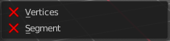
Delete Point
Dissolves the selected vertices. When removing vertices in between then the curve stays intact and connected.

Delete
Deletes the current selection.

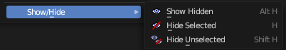
Show/Hide
Sub-menu with shows or hide selection, unselected or hidden operators.

Show Hidden
Makes all geometry in the scene visible again.

Hide Selected
Hides the selected geometry.


Last Operator Hide Selected

Unselected
Hides the not selected geometry.

Hide Unselected
Hides the not selected geometry. The selected geometry stays visible.

